
Query Genie Complete

Documentation

Contents

- Overview
- Architecture
- Features
- Getting Started
- Installation Guide
- User Guide
- Database Support
- Security
- Troubleshooting
- FAQ

1. Overview
1.1 What is Query Genie?
Query Genie is an Al-powered database assistant that revolutionizes how users interact with databases. Instead of writing complex queries, users can ask questions in plain English and receive instant, accurate results presented as interactive tables, charts, and dashboards.

1.2 Key Highlights
- Natural Language Processing: Convert plain English questions into database-specific queries
- Multi-Database Support: Works with 1 1 + data sources including SQL databases, NoSQL, and file formats
- Al-Powered: Leverages local Ollama and cloud-based Groq for intelligent query generation
- Enterprise-Ready: Built with security, scalability, and performance in mind
- Visualization Tools: Interactive charts, custom dashboards, and data export capabilities
- Session Management: Save queries, track history, and manage multiple chat sessions

1.3 Use Cases
- Business Intelligence: Quick data exploration and reporting without SQL knowledge
- Data Analysis: Rapid insights from multiple data sources
- Development: Fast database inspection and query testing
- Education: Learn database concepts through natural language interaction
- Team Collaboration: Share queries, dashboards, and insights

1.4 Supported Databases
- SQL: MySQL, PostgreSQL, MariaDB, Oracle, SQL Server, IBM-Db2, SQLite
- NoSQL: MongoDB (metadata), Redis (metadata)
- Files: CSV, Excel

2. Architecture

2.1 System Architecture
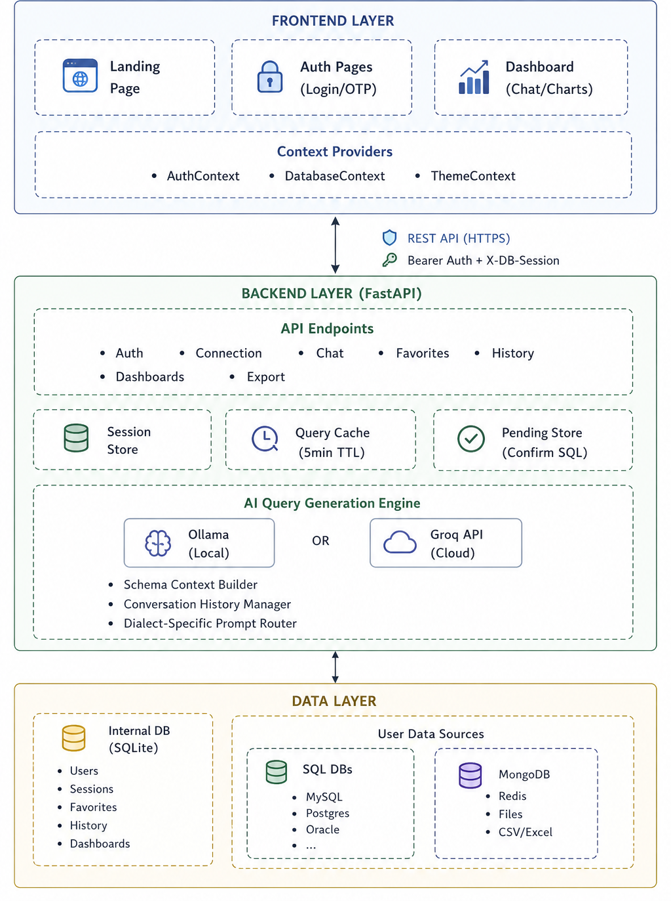

2.2 Query Execution Flow
- User Input: User types natural language question in chat
- Authentication: Request validated with Bearer token
- Database Session: X-DB-Session header identifies connected database
- Context Building: System gathers:
- Database schema (tables, columns, relationships)
- Conversation history (last N messages)
- Database dialect (MySQL, PostgreSQL, etc.)
- Al Generation: Ollama (preferred): Full prompt with rich context And Groq (fallback): Optimized prompt for API limits
- Security constraints
- Execution: Query runs against user's database
- Result Processing: Data transformation
- Caching (5-minute TTL)
- Response: Results returned as JSON with metadata
- Visualization: Frontend renders tables/charts

2.3 Security Architecture
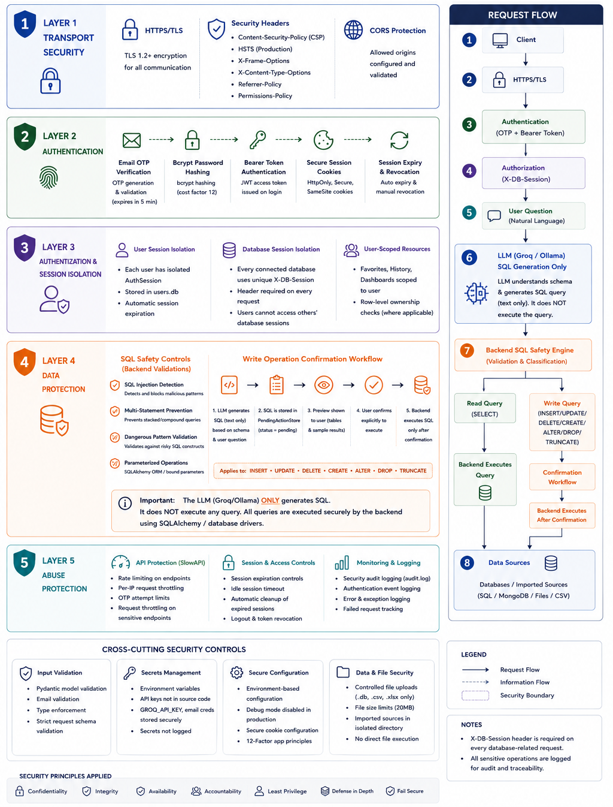

3. Features
- Natural Language Query Interface
- Multi-Database Support
- Automatic dialect detection
- Schema introspection
- Al-Powered Query Generation
- Local Ollama integration for privacy
- Cloud Groq API as fallback
- Query optimization recommendations
- Data Visualization
- Interactive Tables: Sortable columns, pagination, search
- Chart Types:Bar charts, Line charts , Pie charts ,Area charts ,Scatter plots
- Real-time Updates: Live data refresh
- Export Options: CSV, JSON, PNG (charts)
- Custom Dashboards
- Drag-and-drop dashboard builder
- Multiple chart widgets
- Responsive grid layout
- Dashboard templates
- Share and export capabilities
- Query Management
- Favorites: Save frequently used queries with tags
- History: Complete audit trail of all queries
- Sessions: Multiple chat contexts
- Automatic CSV parsing, Excel multi-sheet support, Temporary SQLite staging
- Schema auto-detection
- Data type inference
- Connection Management
- Multiple database connections per user
- Connection pooling and optimization
- Query result caching (5-minute TTL)
- Schema context caching
- Lazy loading for large datasets
- Pagination support

5. Installation Guide
Uploading MSI file

15. FAQ
Q: Can I use Query Genie with my existing database? A: Yes, Query Genie supports 1 1 + database types including MySQL, PostgreSQL, SQL Server, Oracle, and more.
Q: Is my data secure? A: Yes. Your data is protected through HTTPS encryption, secure authentication, session isolation, and backend validation. The AI only generates SQL queries—it never directly accesses or executes commands on your database; all execution is handled securely by the backend with additional validation and confirmation for sensitive operations.
Q: Can multiple users share the same database connection? A: Each user has isolated database sessions for security.
Q: How do I export query results? A: Click the export button in the results table and choose CSV or JSON format.
Q: Can I create custom visualizations? A: Yes, use the Custom Dashboard feature to create personalized charts and layouts.
Q: Is there a query limit? A: By default, no limit. You can configure MAX RESULT ROWS if needed.
Q: Can I use Query Genie commercially? A: Check the LICENSE file in the repository for licensing terms.
Q: Where can I get help? A: contact the Owner at buradvaibhav5@gmail.com
@ 2026 Vaibhav Burad. Query Genie - Al-Powered Database Assistant
GitHub: github.com/vaibhavburad15/Query-Genie

